Event submission fraud detection

Paul Tanger, Ph.D. and Molly Hardy

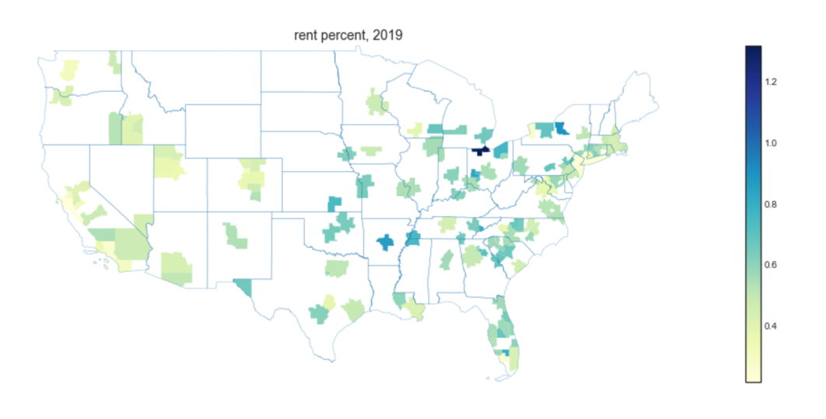**Summary:**

The purpose of this project was

**Project code: Results:**

[github.com/paultanger/Fraud_Detection](https://github.com/paultanger/Fraud_Detection) [interactive web map browser](http://3.128.75.60:33507/)

**Technologies used:**

 